**1A2B (Bulls & Cows) Game Design/Development**

We are about to develop the game, called 1A2B (aka. Bulls & Cows) in Python. The game is played as follows:

1. In the beginning, the game will randomly pick four different digits as the target number (e.g., 2468) to be guessed by the player.
2. In each round of the game, the player can guess four digits, e.g., 1234. If an user-guessed digit hits the target number and its position is the same as that in the target number, it is considered as 1A (or 1 bull). If an user-guessed digit hits the target number but its position is different from that in the target number, it is considered as 1B (or 1 cow).

For example, if the target number is 2468 and the user guessing is 1234, the result of this round is 2B because both digits 2 and 4 hit the target but their positions are wrong. If the user guessing is 2478, the result of this round is 3A because both digits 2, 4, and 8 hit the target number, and their positions are all correct.

1. The player wins the game if his/her guessing results in 4A (or 4 bulls), i.e., all the digits appear in the target number, and their positions are correct.

The screen shot of the game could be as follows:

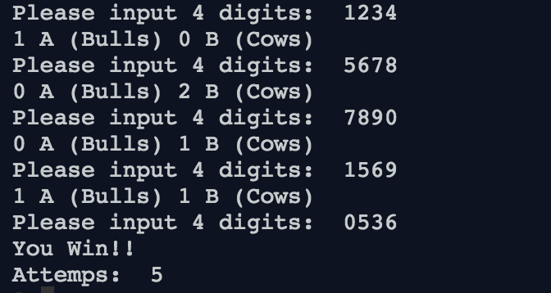

More information about the game: https://en.wikipedia.org/wiki/Bulls_and_Cows

**Discussion 1**

To play the 1A2B game, what are the steps (procedures) needed? What is the flow of them? Come up with your design (algorithm) by pseudocode/flowchart first.

**Discussion 2**

Based on your design, define the prototype of functions corresponding to each step.

* What is the functionality?
* How many parameters? What are they?
* The return object of the function

**Discussion 3**

Implement each function according to your design.

**Discussion 4**

Combine all functions you developed to complete the game.